Badges & Achievements
1 What I'm proposing
A badge layer on top of what already exists: 31 badge families (52 undiscovered) covering every feature, straight from the Badge Workbook. Deliberately few, so each one means something. Three shapes cover everything:

Badge type | When it's used | Real example from the workbook
Progressive | Volume builds over time | Step Collector: Bronze → Platinum at 100K / 500K / 1M / 5M lifetime steps (+50/100/250/500 Hc)
One-time | The act itself is the achievement | First Steps (first sync, +50) · 10K Day (first 10,000-step day, +100)
Repeatable | Repetition is the point | Sync Champion ×N — every 7-day sync run (+50, paid up to 4×/month) · Health First — each rolling year

2 Badge user journeys
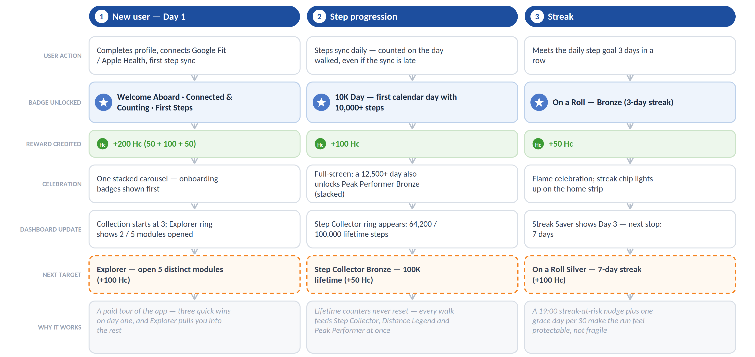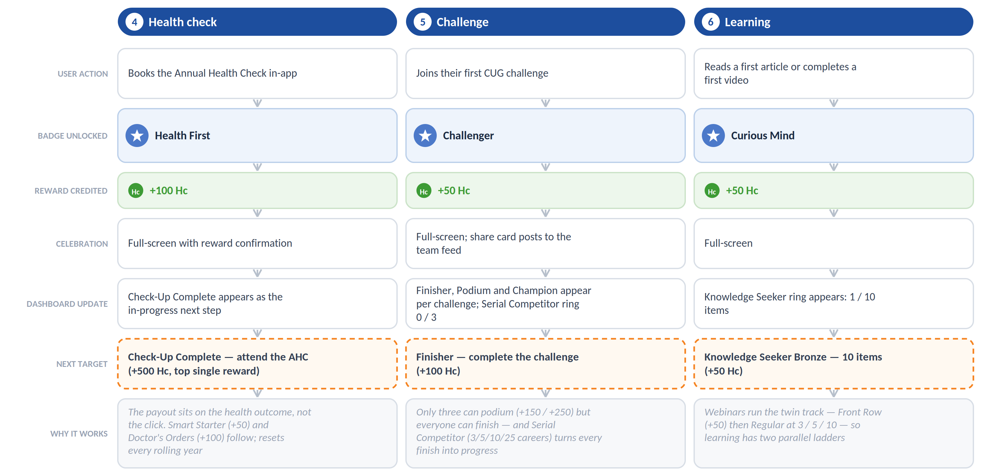

3.1 How badges chain into each other

No badge is a dead end — each unlock leaves the next one already in progress:

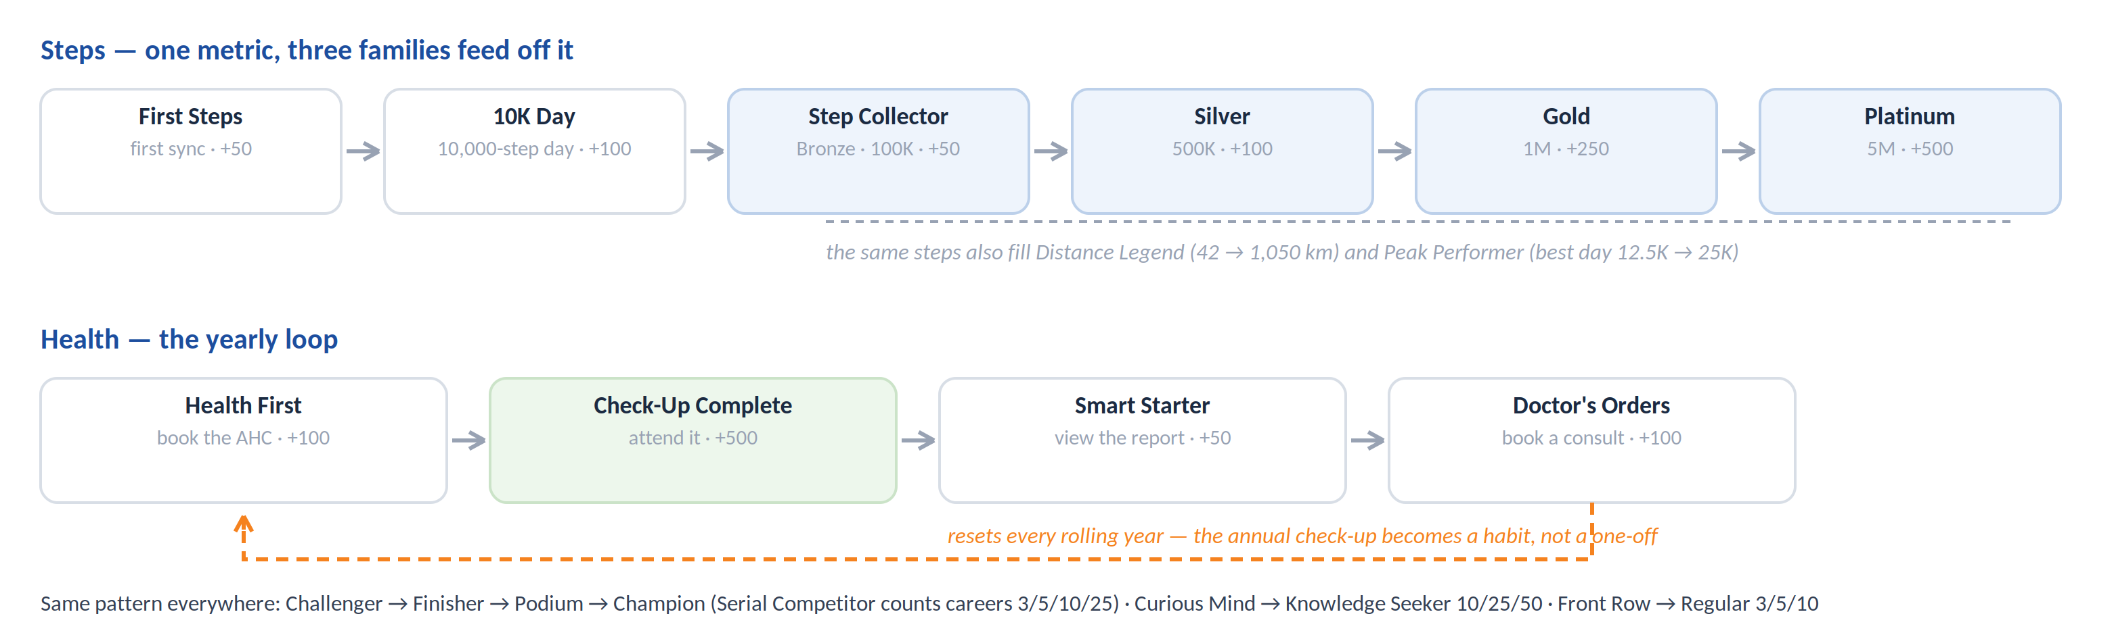

3.2 A first 90 days, mapped out

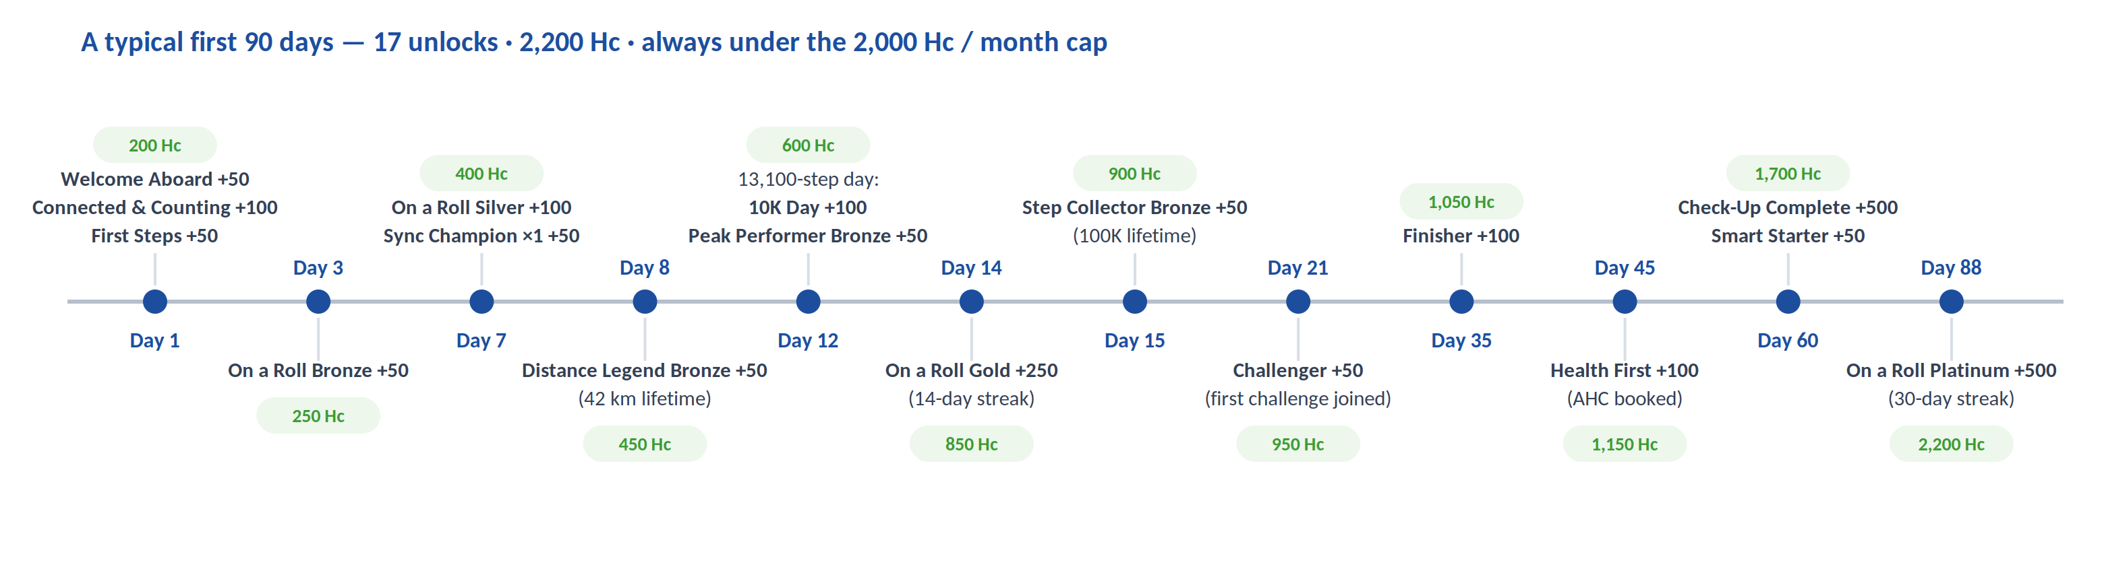

3.3 Category map — earn it, get paid, chase the next one
Category | Entry badge — how it's earned | UI change on earning it | Next target
Onboarding & Discovery | Welcome Aboard — complete profile with photo + daily goal (+50 Hc) | Collection starts; hub card flips to earned | Connected & Counting (+100), then Explorer — open 5 modules (+100)
Steps & Distance | 10K Day — first day with 10,000+ steps (+100) | Step Collector ring appears with live lifetime count | Step Collector Bronze — 100K lifetime (+50)
Streaks & Consistency | On a Roll Bronze — goal met 3 days straight (+50) | Streak flame + day counter light up on home | On a Roll Silver — 7 days (+100); Sync Champion each 7-day sync run (+50)
Challenges | Challenger — join your first challenge (+50) | Finisher / Podium / Champion listed per challenge | Finisher — complete it (+100); Serial Competitor Bronze at 3 (+50)
Health & AHC | Health First — book your Annual Health Check (+100) | Check-Up Complete moves to in-progress | Check-Up Complete — attend it (+500, top single reward)
Events & Facilities | Front Row — attend your first webinar (+50) | Regular ring shows 1 / 3 webinars | Regular Bronze — 3 webinars (+50); Game On — first facility booking (+50)
Content & Learning | Curious Mind — first article read or video completed (+50) | Knowledge Seeker ring shows 1 / 10 items | Knowledge Seeker Bronze — 10 items (+50)
Community & Social | Moment Maker — publish your first post (+50) | Cheerleader & Crowd Favourite appear with live counters | Cheerleader — give 25 reactions (+50); Crowd Favourite — receive 50 (+100)
Seasonal & Campaign | Campaign Finisher — meet an admin-set goal inside the window (admin-set Hc) | Campaign card with countdown appears in hub | Whatever the next campaign brings (Festival Stepper template)

4 How we'd measure it

Baselines during the pilot, review 90 days after full rollout:
Metric | Target | Metric | Target
Daily / weekly active users | +8–15% | Day-30 retention | +5–10%
Step-sync days / user / week | +20–30% | Challenge joins | +10–20%
Time to first badge | < 2 days from signup | Hub visits, weekly | > 35% of weekly actives
Celebration → share rate | > 8% | AHC bookings + completion | above last year

5 Where I'd put it — screen by screen

5.1 Quick Action card

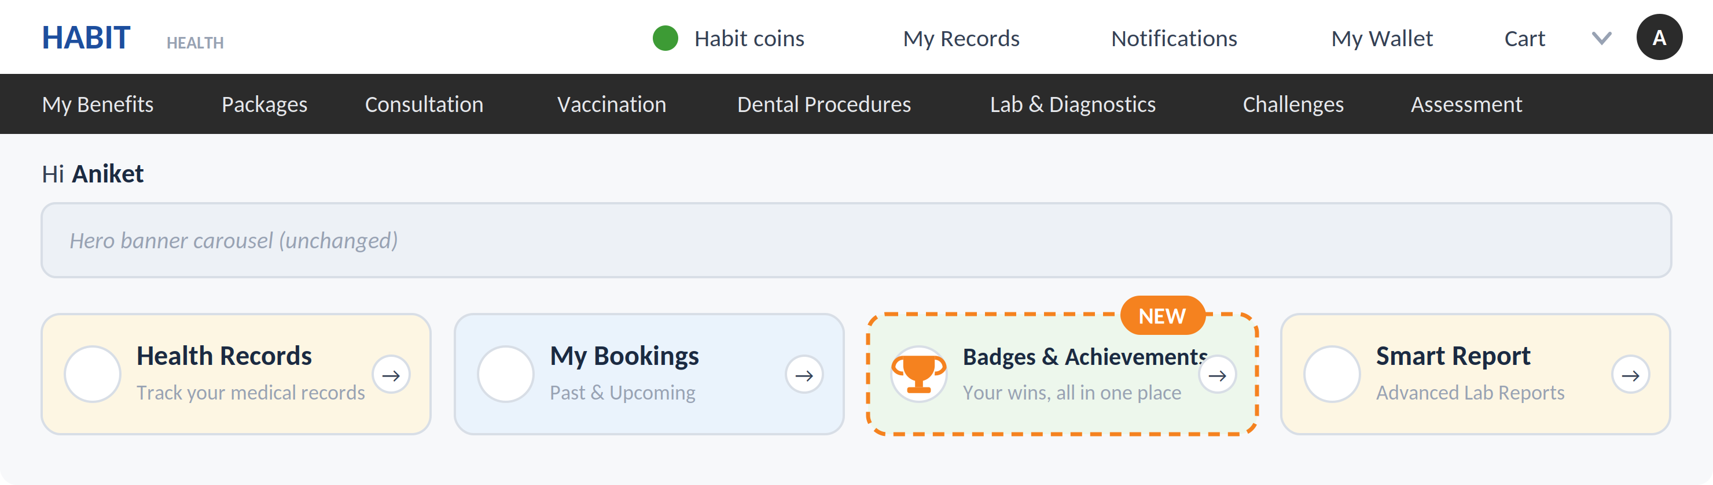

5.2 Home achievements strip

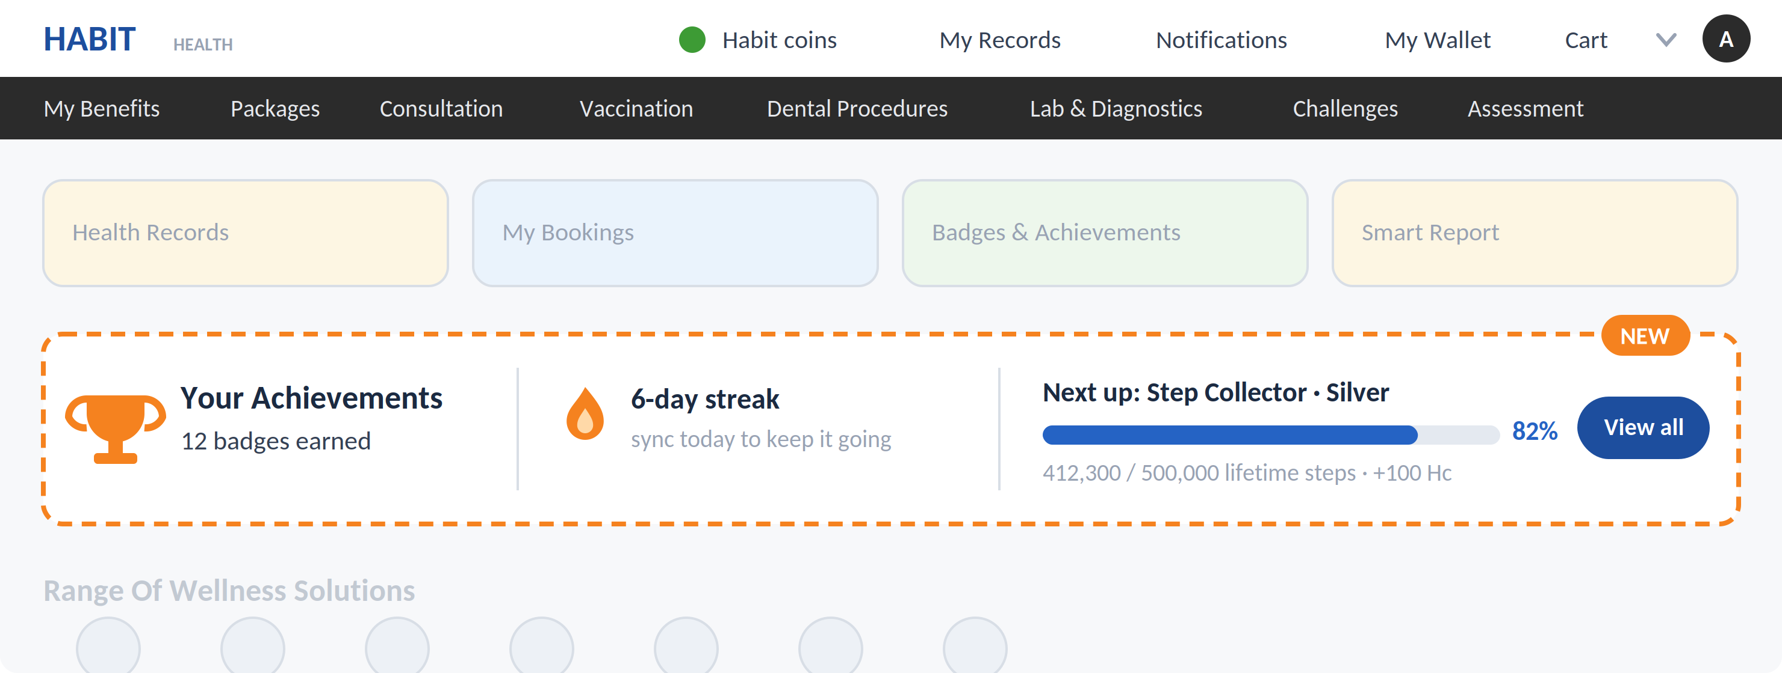

5.3 Streak Saver — next to the Daily Step Goal

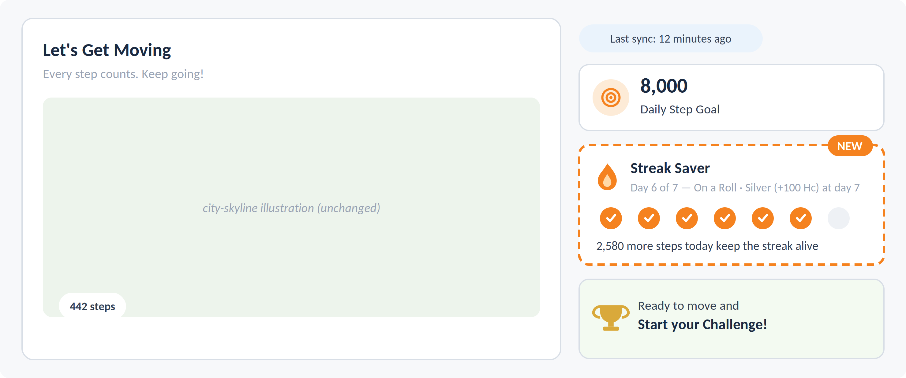

5.4 + 5.5 Profile menu entry · Unlock popup
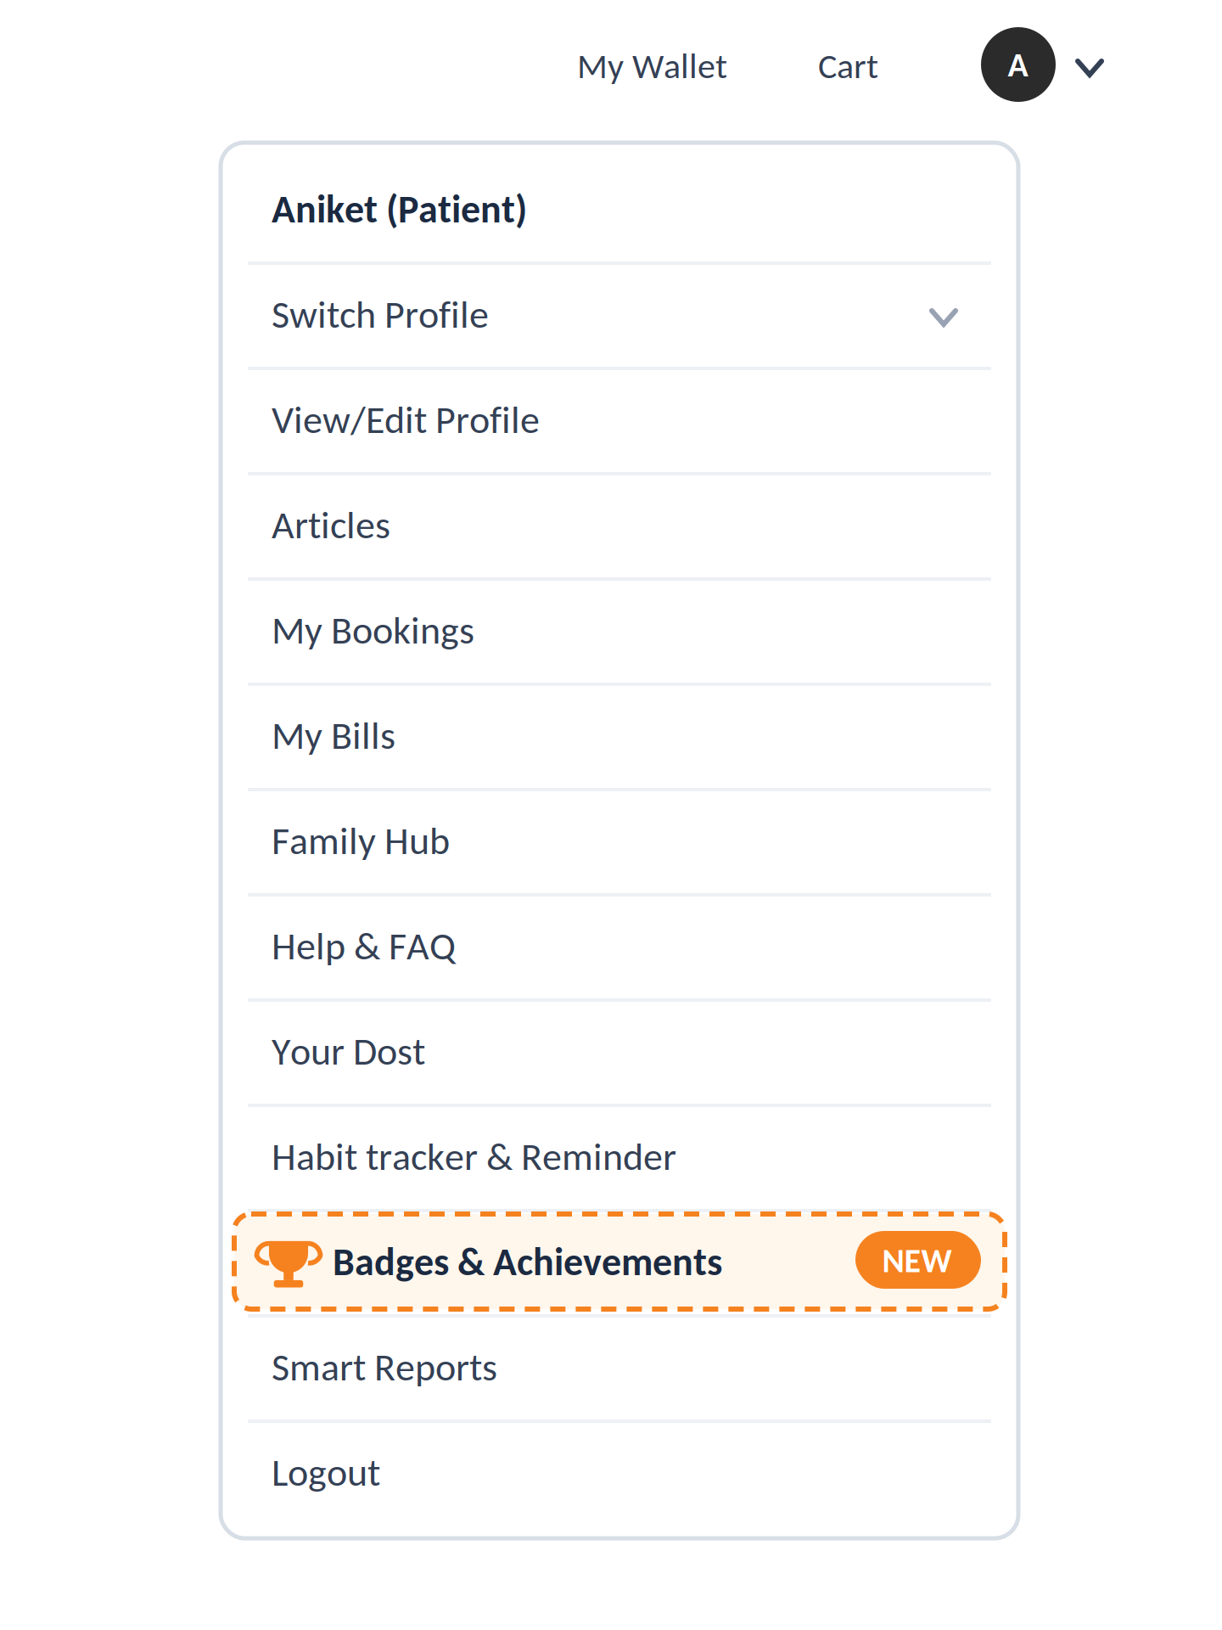 | 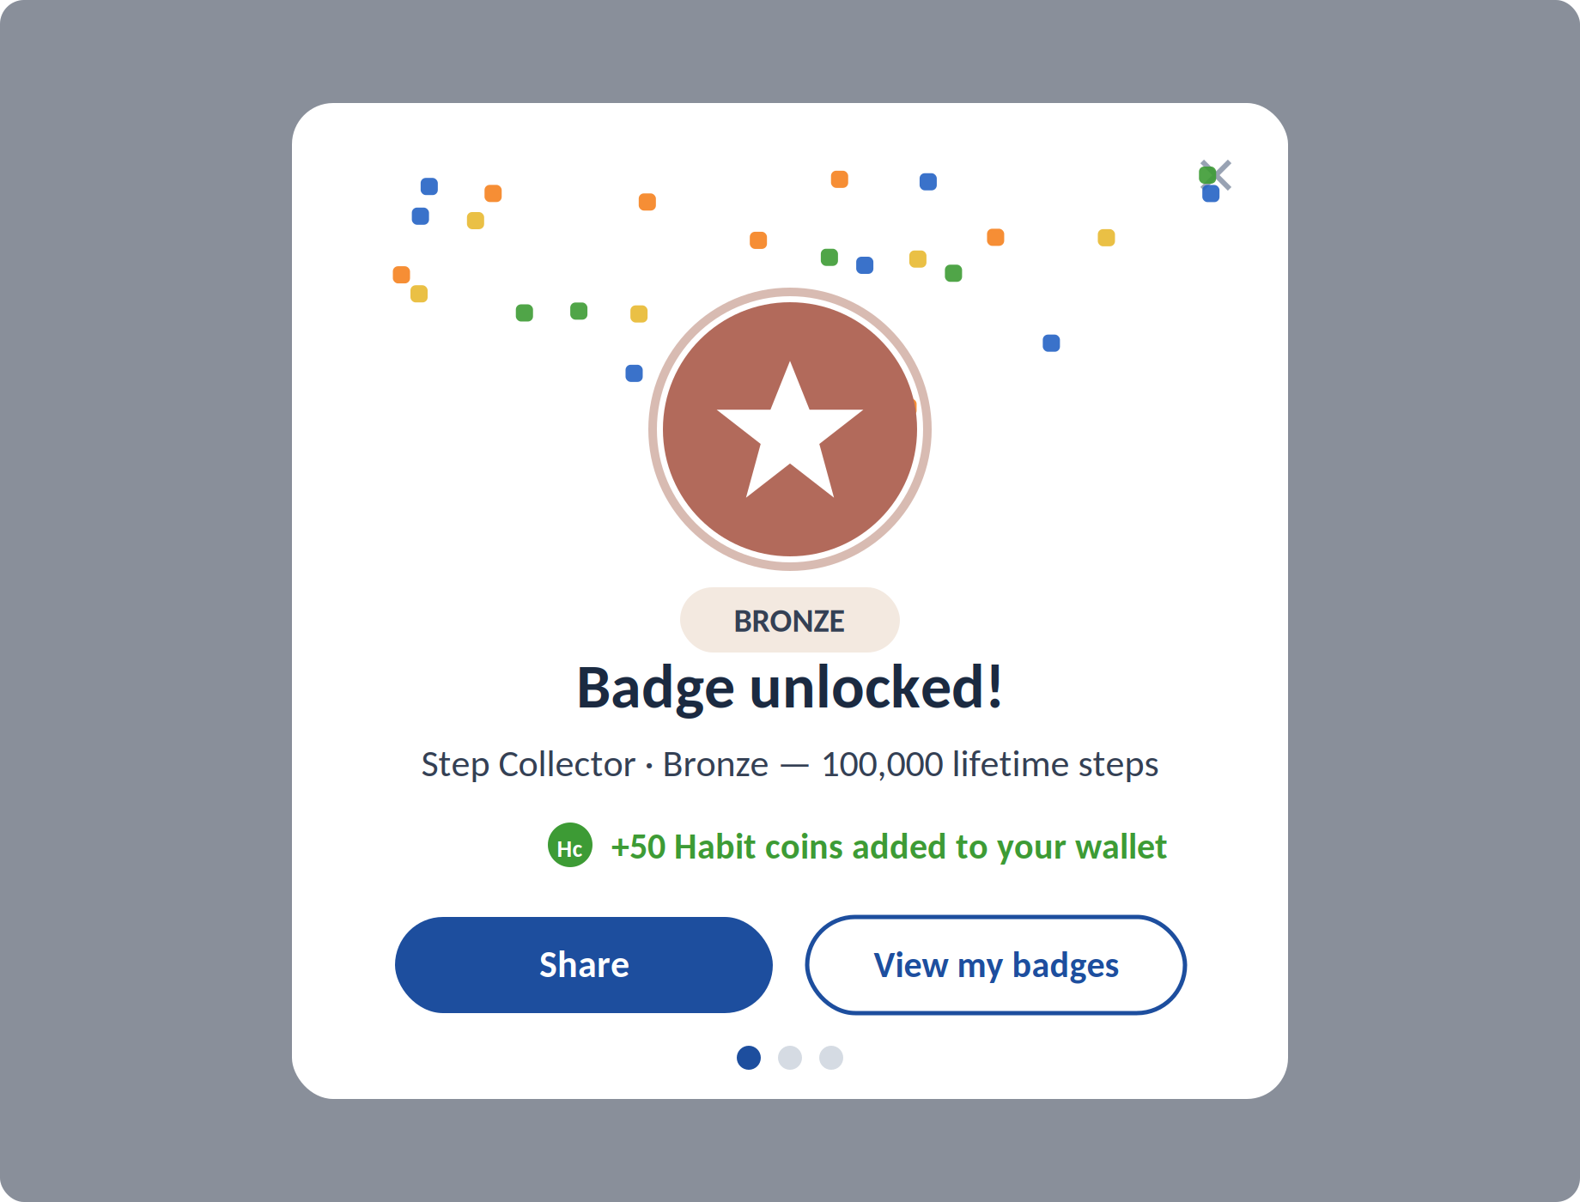

5.6 The Badges & Achievements hub

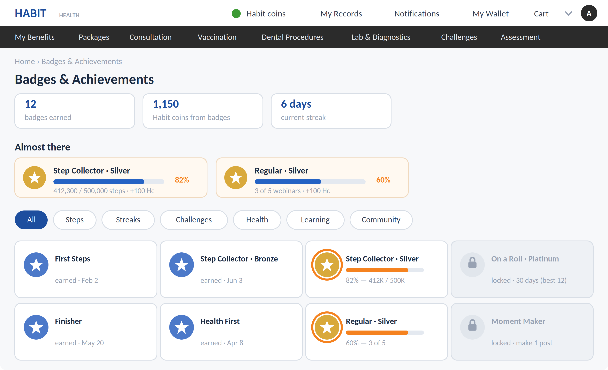

5.7 Badge detail — the tier ladder

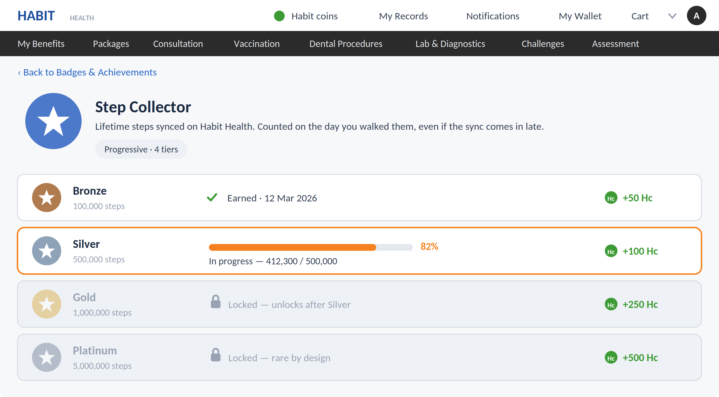

6 Badge Integration in Play Section

6.1 Before joining a challenge

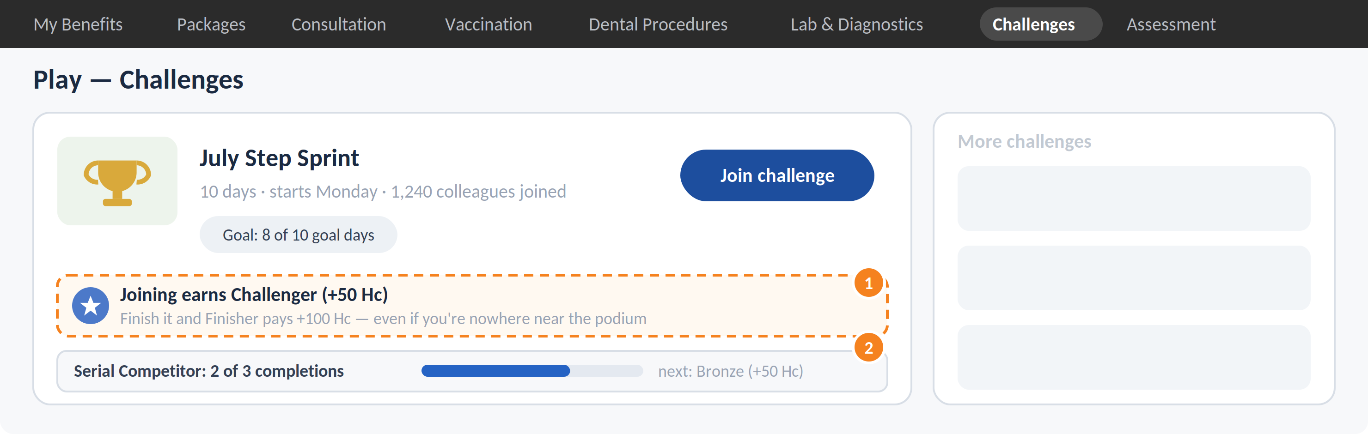

6.2 During a challenge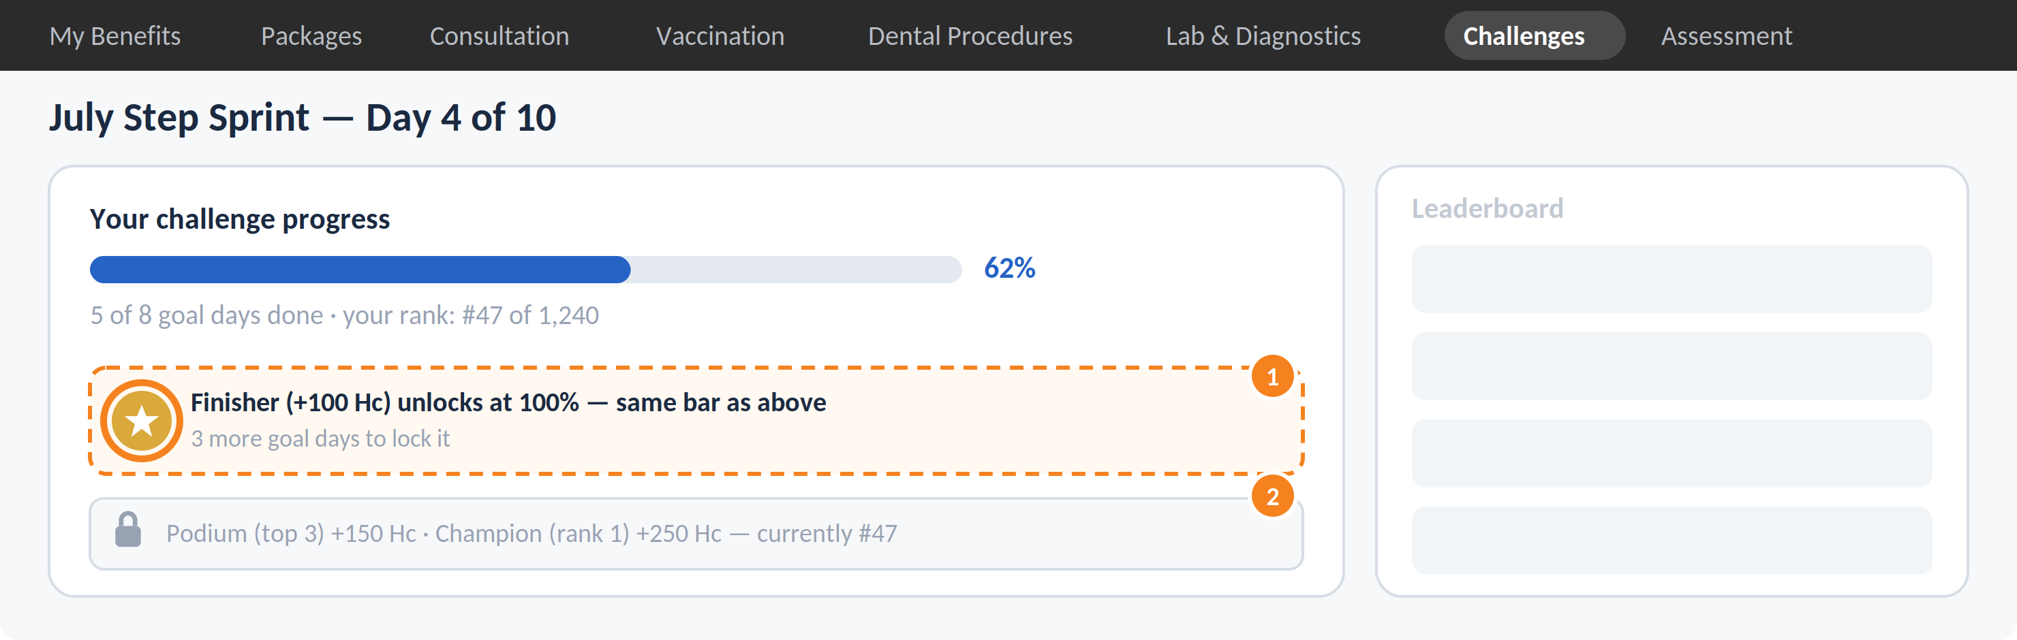

6.3 After completion of any challenge

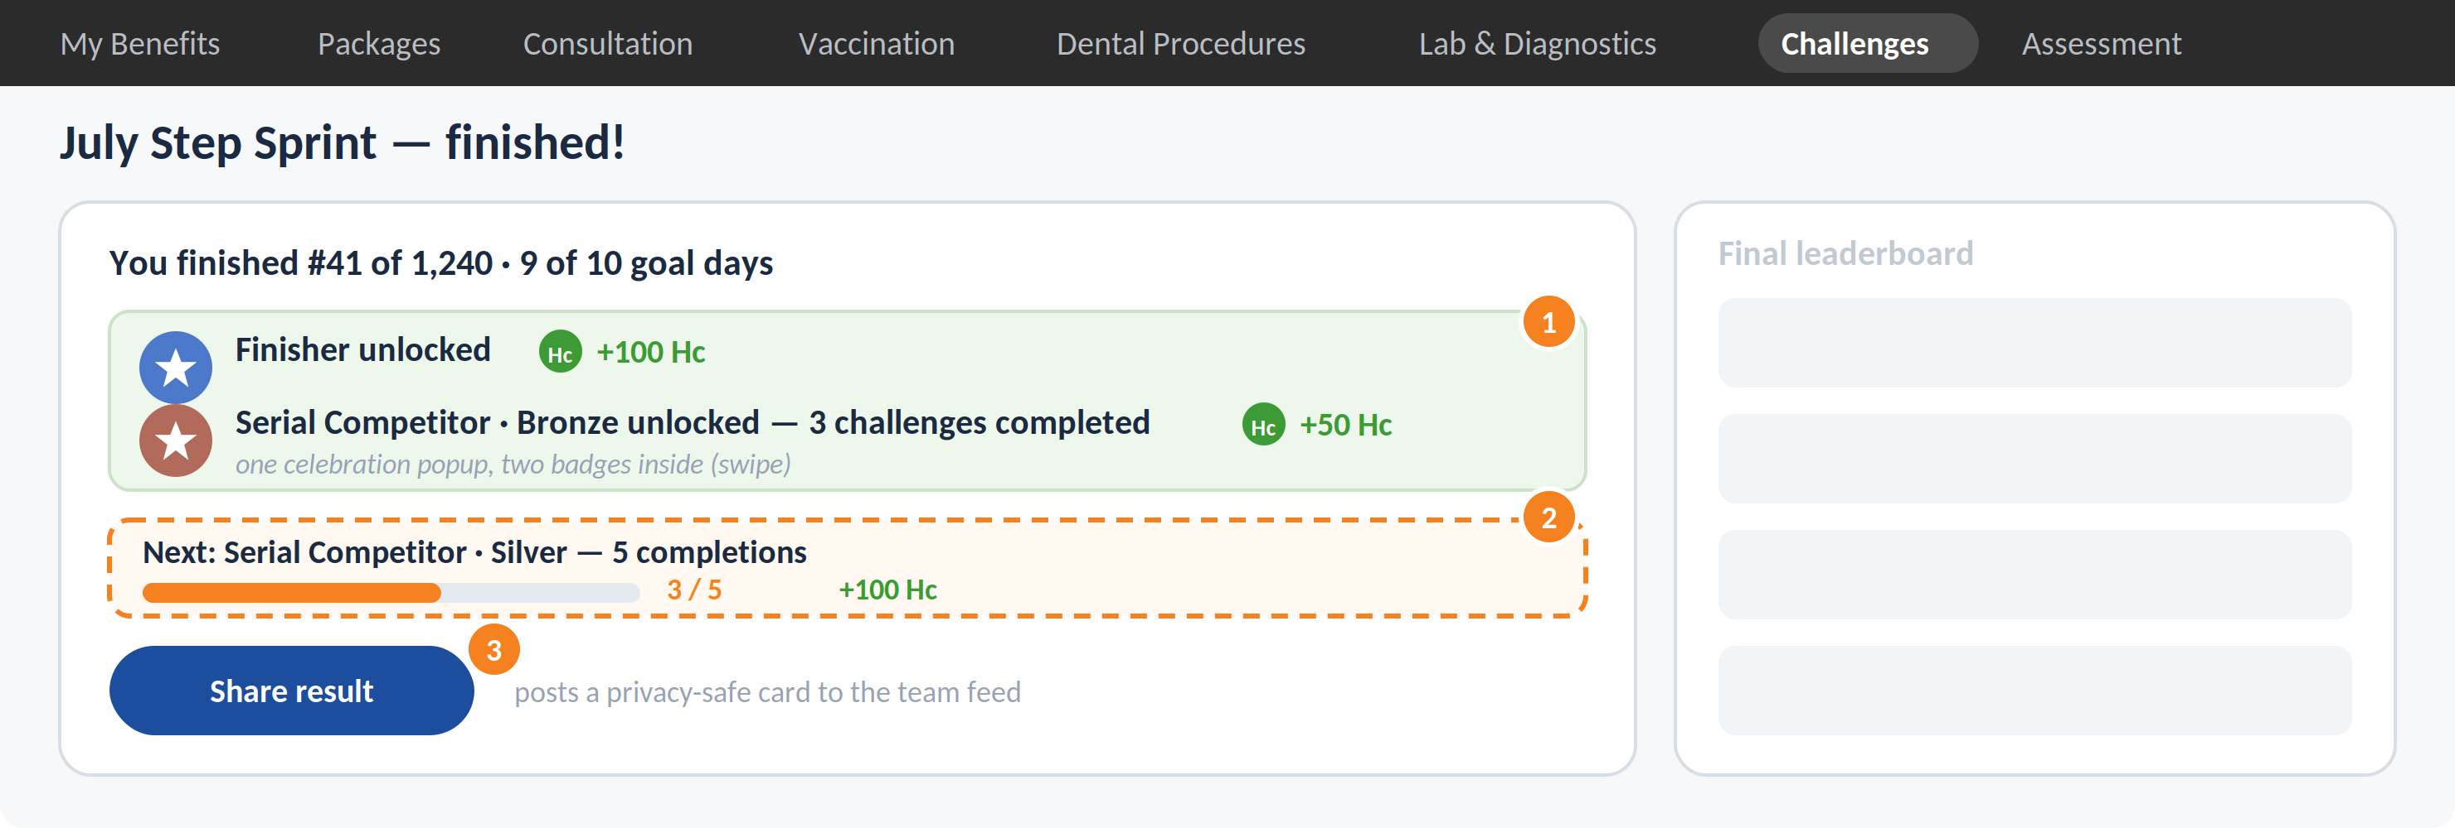

1 One popup, two badges: Finisher (+100 Hc) and Serial Competitor Bronze (+50 Hc) land together.

2 The next rung — Silver at 5 completions — is on screen before the confetti clears.

3 Share posts a privacy-safe result card to the team feed: free promotion for the next challenge.

7 What ships first, what waits
Ship in v1 | Wait — and why
- 31 badge families / ~52 instances across 8 categories  - Habit-coin rewards, credited automatically on unlock  - Celebration popup + share cards (no health numbers on the card)  - Hub, home surfaces, profile-menu entry, Play integration (sections 5–6)  - Backdated badges at launch as one “journey so far” recap — nobody starts with an empty page  - Client Admin badge builder with approval flow (at full rollout) | - SPL & team badges — needs team features that don't exist yet (later catalogue rows, no engine change)  - Quest chains & profile levels — single badges should prove out first  - Sponsored / partner badges — commercial and compliance groundwork pending  - Hidden “surprise” badges — v1 keeps every badge's progress visible  - Vouchers as rewards — waiting on the voucher inventory API; coins and wallet cover launch

